INTRODUCTION

For Indonesia, Digital Financial Services (DFS) may well be the next big thing, combining existing mobile phone usage and the country’s increasing appetite for financial services. The prospective entry of millions of unbanked and underbanked consumers into the financial system is the result of the increasing prevalence of mobile devices. DFS not only promises accelerated economic growth in Indonesia, but also will yield significant changes in business practices and replace traditional methods of financing. Most importantly, DFS will likely extend its reach beyond major city centres and into the provincial hinterland, where the bulk of unbanked and underbanked consumers reside. Globally, approximately 2.5 billion people do not have formal accounts at a financial institution, with 65% and 58% of the population in Latin America and South Asia considered unbanked respectively.1 While the DFS market is nascent in Indonesia, it is well-developed in other countries with large unbanked populations. A full appreciation of the market opportunity for DFS in Indonesia requires an understanding of successful models in other countries, DFS’ national and local impact across Indonesia, and critical success factors for DFS deployment in the country.

In Indonesia, DFS offers opportunities for an estimated110 million bankable unbanked citizens in the country to access banking services and products.3 With the increase in mobile phone usage, Internet penetration in Indonesia is expected to grow rapidly and reach 100 million users in the next three years.4 These developments will present enormous prospects for market participants in the DFS market space. Understanding the DFS’ impact on the Indonesian economy, especially at the provincial level, will enable market participants to develop tailored DFS strategies in Indonesia. Local Indonesian insights and knowledge of DFS paradigms in other markets help establish a better understanding of the key success factors needed to implement DFS in Indonesia. These factors vary for the private and public sectors. Private sector participants such as financial services institutions and telecommunications companies have a direct role to play in driving DFS adoption and promoting financial literacy for the unbanked. Meanwhile, the public sector can help build the infrastructure to make the DFS eco-system possible. The partnership between the private and public sectors is critical to the success of Indonesia’s digital revolution in financial services.

MOBILE MONEY

For the last couple of years, we often heard the term “Cashless Society” being promoted by Bank Indonesia (BI). BI as Indonesia’s central bank initiated a movement called *“Gerakan Nasional Non-Tunai”*(National Cashless Movement) back in 2014, with goals such as providing convenience to users and more importantly, reducing the handling cost of financial institutions. David Wolman in his book “The End of Money” stated that cash transactions are costly, and[they are the main “nemesis” for banks](http://on.wsj.com/2smMAFE), because banks need to count cash manually, hence increasing banks’ operating costs. In a macro scale, non-cash transactions are making economy more efficient by [making the handling process that has been done by businesses and governments becoming more transparent and accountable](http://bit.ly/2Ejqh9y) (Kompas, 2016).

We believe that the constant push from this cashless movement and the increasing trend of smartphone penetration in Indonesia will lead to the next big trend: Mobile Payments. People, especially the younger generations, are inseparable from their mobile phones. A research conducted by Qualtrics and Accel stated that millennials are checking their phones [150 times per day](http://on.inc.com/2slYb81) (Inc, 2017). A research by Statista in 2017 predicted that mobile payment transaction value will be reaching US$ 59 Mn by 2021 with 85% CAGR.

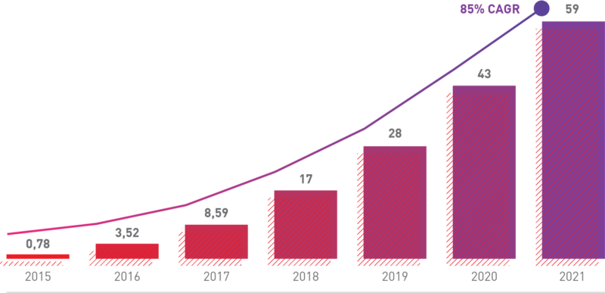

Figure 1: Forecast of Indonesia Mobile Payment Transaction Value — Source: Statista (2017)

However, for this vision to come into fruition, “cashless habit” should be developed. We all know that cash is still the king as the most popular payment method in Indonesia, where according to eMarketer, [65.3% of Indonesian consumers](https://www.emarketer.com/Article/Cash-on-Delivery-Still-Wins-Among-Digital-Shoppers-Indonesia/1015767) are still choosing cash on delivery as the payment instrument for digital purchases. Hence, developing a habit of paying for goods cashlessly will be very challenging and costly. We can see from Figure 2 that from the top 10 most popular mobile payment brands in Indonesia, almost all of them are backed by big-name investors and/or corporations with a lot of cash to burn (Go-Jek’s Go-Pay is backed by KKR & Warburg Pincus; Grab’s Grabpay is backed by Softbank; Telkomsel’s T-Cash is owned by Telkom Indonesia; etc).

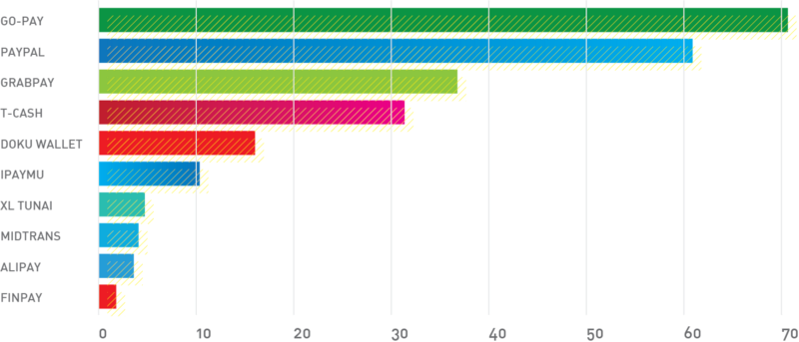

Figure 2: The most popular mobile payment brand in Indonesia. Source: [Financial Times](http://s.nikkei.com/2sn6L6r)

Most mobile payment services in Indonesia right now are subsidizing every transaction through cashbacks, discounts with merchants, and price cuts to increase usage. This highly competitive market — plus the tight government regulations for mobile payment licenses — in the end will create an oligopolistic market structure, and making it almost impossible for early-stage startups without any prominent backers to enter the market and succeed. Benchmarking to China market, there are only 2 big mobile payment players — Alipay & WeChat Pay — controlling [almost 90% of mobile payment market share](http://on.wsj.com/2nRxa7B) (WSJ, 2017).

This phenomenon should raise a lot of questions about whether “cashless society” is another hype bubble. Prices in the fintech and mobile payment industry are definitely inflating, but we believe that it can be justified, if we put mobile payment platforms’ ability to capture consumer data and use it for other multiple use cases.

From the case studies in China, one of the best use cases that we can learn is from Alibaba on its ability to use its consumer data that has been gathered from its mobile payment platform Alipay over the years, to cross-sell other financial products. One of the best examples is how Ant Financial — Alibaba’s financial technology arm — has successfully grown Yu’e Bao, its money market fund, to become the largest money market fund in the world with [370 million account holders and US$211 Bn in assets in just 4 years](http://on.wsj.com/2Ce0GJ5) (WSJ, 2017) — more than twice the size of JP Morgan. Its ascent has been a byproduct of a sharp shift among Chinese consumers toward mobile payments. Yu’e Bao draws its funds from users of Alipay, using its data algorithm to target the right users that match Yu’e Bao’s investment profile and providing generous returns. We can imply that this use case is driving financial inclusion in China, as it entices Alipay users, which is roughly at the size of one-third of China population, to start investing their money into multiple financial instruments.

We believe that this data-leveraged algorithms that can be used for multiple use cases is the reason why the mobile payment players are making huge investments into user acquisitions and usage, because whoever gets more data and finding the best use cases to leverage the data is the one who will be dominating the market.

LINKS-

<https://www.gsma.com/mobilefordevelopment/wp-content/uploads/2013/10/Implementing-mobile-money-interoperability-in-Indonesia.pdf>

<http://www.mdi.vc/mobilepaymentindonesia.pdf>

<https://www2.deloitte.com/content/dam/Deloitte/sg/Documents/financial-services/sea-fsi-digital-financial-services-in-Indonesia-noexp.pdf>

ELECTRONIC MONEY

In response to the vast growth in technological innovations and the tendency of businesses to integrate in order to create business ecosystems, Bank Indonesia has issued a new Electronic Money Regulation. It seeks to anticipate the risks associated with the e-money business by implementing risk management and security standards, and increasing supervision over e-money business players. The foreign ownership limits introduced by the Regulation are arguably the most crucial point in the Regulation, and may cause Providers to restructure their e-money businesses.

In response to the vast growth in technological innovations and the tendency of businesses to integrate in order to create business ecosystems, Bank Indonesia (**BI**) issued Regulation No. 20/6/PBI/2018 dated 3 May 2018 on Electronic Money (**Regulation**). The Regulation seeks to anticipate the risks associated with the e-money business by implementing risk management and security standards, and increasing supervision over e-money business players. The foreign ownership limits introduced by the Regulation are arguably the most crucial point in the Regulation, and may cause Providers to restructure their e-money businesses.

The Regulation revokes the previous regulations on the same subject and is effective as of 4 May 2018. E-money licences issued before the enactment of the Regulation remain valid for five years after the effective date of the Regulation. Non-bank e-money issuers who already have a licence need to comply with the minimum capital requirements (as discussed below) within six months following the effective date of the Regulation (by 4 November 2018, at the latest).

Some key takeaways of the Regulation are as below:

**Controlling shareholder restrictions**

Under the Regulation, e-money service providers (the **Providers**) comprise: (i) issuers; (ii) acquirers; (iii) principals; (iv) switching providers; (v) clearing providers; and (vi) settlement providers. Issuers and acquirers are considered front-end providers, while the rest are back-end providers. A Provider can only provide services in either the front-end or the back-end. For example, an issuer can also be an acquirer, but cannot be a principal. The rationale for this grouping is to avoid potential conflicts of interest in operating front-end as well as back-end services.

In addition, a party cannot become a Controlling Shareholder of non-bank Providers with the same licence (e.g. licence as e-money issuer). A party also cannot become a Controlling Shareholder of non-bank Providers that operate in both ends. The Regulation defines ‘**Controlling Shareholder**’ as a shareholder holding 25% or more shares with voting rights, or a shareholder holding less than 25% but having direct or indirect control. The definition is not entirely clear on whether an ultimate parent company of a group is considered a Controlling Shareholder of all the companies within the group. However, the restrictions seem to aim at restricting companies within the same group from (i) holding more than one e-money licence; and (ii) operating in different ends.

**Foreign ownership restrictions**

A non-bank e-money issuer is subject to a maximum 49% foreign ownership. The calculation of the foreign ownership percentage includes direct or indirect ownership as assessed by BI, for which BI will look to the ultimate shareholder or beneficial owner level, and take into account, among others, the benefits to the Indonesian economy. It is not clear yet how BI will implement the assessment of indirect ownership, e.g. whether a shareholding by a foreign investment company (**PMA company**) in an e-money issuer will be considered foreign ownership. To compare this with the general foreign investment regime, under the Indonesia Investment Coordination Board (BKPM) Regulation No. 13 of 2017 on the Guidelines and Procedures for Investment Licensing and Facilities, investments made by a PMA company are considered investments by a foreign direct investment. In other words, shareholding by a PMA company in another PT will be considered foreign ownership.

For a non-bank e-money issuer that is a public company, BI will only assess those shareholders holding 5% or more shares in such public company. This seems to suggest that even a public company (which is a non-bank e-money issuer) is also subject to the foreign ownership limit.

A non-bank e-money issuer that obtained its licence before the enactment of the Regulation needs to comply with the 49% foreign ownership limit if there is a change of ownership that results in the change in the foreign ownership. With the language used being ‘change of ownership’ and not ‘change of control’, it seems that BI intends to catch any change in shareholding composition of the non-bank issuer, regardless of the percentage.

BI, at its discretion, can also set a different foreign shareholding limit for a non-bank e-money issuer, subject to the applicable maximum limit of 49%. This can be read as if BI can restrict the foreign ownership limit even more, but not relax it.

**Minimum capital requirements vis-à-vis floating fund**

To control and mitigate liquidity and insolvency risks, the Regulation stipulates certain minimum paid-up capital and placement of Floating Fund requirements for a non-bank e-money issuer. **Floating Fund**is defined as the entire e-money value held by an e-money issuer as a result of the e-money issuances and top-ups that remain the liabilities of the e-money issuer towards the users and merchants.

The Regulation requires that, during the licence application process, a non-bank e-money issuer must have a paid-up capital of at least IDR3 billion. Afterwards, the paid up capital needs to be adjusted as below:

* If the Floating Fund is more than IDR3 billion up to IDR5 billion, the minimum capital is IDR6 billion;
* If the Floating Fund is more than IDR5 billion up to IDR9 billion, the minimum capital is IDR10 billion; and
* If the Floating Fund is more than IDR9 billion, the minimum capital is IDR10 billion plus 3% of the Floating Fund.

In addition, a non-bank e-money issuer needs to place a minimum 30% of the Floating Fund in a checking account (*giro*) in the BUKU 4 Category domestic banks (currently Bank Mandiri, BRI, BNI and BCA), subject to its monthly average liquidity requirements. For example, if a non-bank e-money issuer’s monthly average liquidity requirement is 25% of its Floating Fund, then the minimum 30% limit, as above, applies. However, if its monthly average liquidity requirement is 45%, then the minimum limit becomes 45%. The remaining portion of the Floating Fund (i.e. a maximum of 70%) must be placed in securities or financial instruments issued by the Government or BI, or in an account with BI.

**Lock-up period**

A non-bank Provider is prohibited from making a corporate action that can cause a change in its controlling shareholder to within five years as of the issuance of its e-money licence. An exemption may be granted by BI on a case-by-case basis, for example, if the Provider is suffering from financial difficulties and needs capital injection to survive.

The rationale for this restriction is to avoid the practice of what BI dubs ‘licence brokerage’. Given that BI carefully scrutinises all applications for e-money licenses, some business players believe that it would be much less time-consuming to simply buy a company that already has a licence. This lock-up period is an attempt to avoid applicants applying for a licence with the intention of selling the company forthwith to a buyer who wishes to get the licence without having to go through the application process with BI.

**Closed-loop-specific rules**

The Regulation recognises **closed-loop e-money**, which is defined as e-money that can only be used as a payment instrument for goods/services of the e-money issuer. Closed-loop e-money issuers with a Floating Fund of less than IDR1 billion are not subject to a licence requirement from BI. However, if an e-money issuer issues more than one closed-loop e-money product, for the purpose of the IDR1 billion threshold, the size of the Floating Fund is the aggregate Floating Fund of all closed-loop e-money products issued by such e-money issuer.

Bank Indonesia is campaigning for the shift to the National Payment Gateway card.

Indonesia’s central bank has been actively campaigning for its residents to have their debit cards and electronic money cards exchanged for the National Payment Gateway (GPN) card, reports The Jakarta Post.

Also read: [Indonesian banks shoulder growing bad debt burden](https://asianbankingandfinance.net/retail-banking/news/indonesian-banks-shoulder-growing-bad-debt-burden)

The mass production and use of debit cards with the GPN logo in electronic data capture (EDC) terminals are expected to be carried out by the second half of the year, Artajasa Pembayaran Elektronis business director Anthoni Morris told TJP.

Also read: [How are ASEAN banks deploying real-time payment systems?](https://asianbankingandfinance.net/cards-payments/news/chart-week-how-are-asean-banks-deploying-real-time-payment-systems)

Launched in late 2017, GPN’s interconnected payment ecosystem allows customers to perform transactions like cash withdrawals from banks other than their own for a minimal cost. Prior to GPN’s roll out, debit cards can only be used on devices from the same bank.

Interbank transactions can also be made but are subject to an administrative fee around 2-3% of transaction value.

The application of GPN can save costs per transaction of up to $124.32m (Rp1.8t) per year, according to a report by the Ministry of Communication and Information Technology, as well as slash the value of domestic payment transactions that are performed overseas.

From an estimated transaction value using debit card with MasterCard and Visa of 1.73m (RP25b), transactions via foreigners through GPN were reduced to $1.22m (RP 17.7b) per day with the use of GPN.

Merchants can also save up on costs as they will no longer need to supply as many EDC machines in cash registers as customers can now make transactions with any EDC machine.

As of end-June, a total of 95 banks have already complied with regulatory requirements and linked up with two switching companies.

According to data from the central bank, around 937,000 GPN debit cards have already been printed with 497,000 already being issued to the public. BI targets around a third of the total commitment of NSICCS cards can be completed by the end of 2018.

Customers can exchange their existing debit cards with GPN debit cards in their respective bank and other exchange facilities held by banks free of charge.

LINKS-

<http://www.thejakartapost.com/life/2016/11/07/what-you-should-know-about-e-money-growth-in-indonesia.html>

<https://www.thinkwithgoogle.com/intl/en-apac/tools-research/research-studies/all-eyes-e-money-race-reach-180m-unbanked-indonesians/>

<https://assets.kpmg.com/content/dam/kpmg/id/pdf/2017/01/id-retail-payments-in-indonesia.pdf>

**Mobile Wallets & Payment Systems**

* The early adoption of mobile payments in Indonesia compares favorably with the take-up of earlier cashless payment systems, suggesting consumer enthusiasm.
* A supportive regulatory environment has spurred open competition and the use of different technologies.
* The adoption of QR codes will boost access to financial services in 2018.

Billed as the fastest growing mobile-commerce market in the world, Indonesia is poised to benefit from an explosion in mobile payment use next year. There are three main factors behind the coming surge.

First, consumers are ready. FT Confidential Research's latest survey of 1,000 urban consumers in 25 Indonesian cities revealed about a third used mobile payments at least once in the three months to the end of September. As expected, the adoption rate is higher in Java, the island that generated almost 58.5 per cent of Indonesia's GDP in 2016, compared with the rest of the country (see chart).

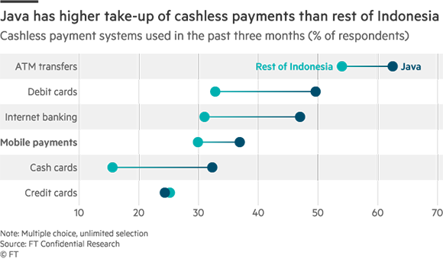

Income levels also influence the use of mobile payments. Consumers in the middle income category and above - those who earn more than Rp60m ($4,400) a year - had an adoption rate of more than 46 per cent (see chart).

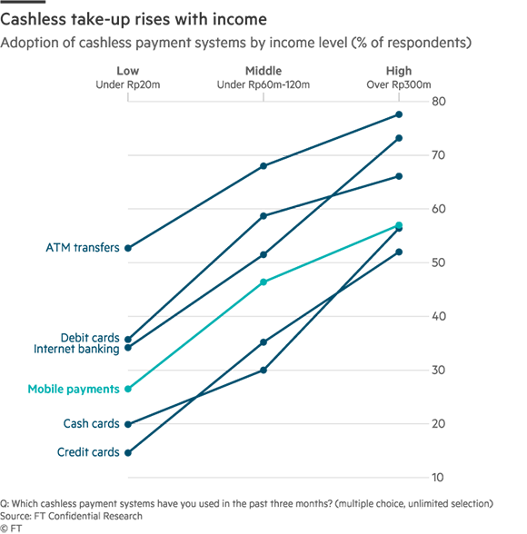

The overall adoption rate is promising, considering that mobile payment systems only became widely available in the past two years with the launch of Go-Pay and T-Cash, the e-wallet services from, respectively, Go-Jek, Indonesia's first unicorn start-up, and Telkomsel, the country's largest mobile phone operator.

**Three-way competition**

Second, all the necessary regulatory support is in place for open competition between banks, telecoms companies and tech start-ups.

As the sole authority on payment systems, the central bank, Bank Indonesia, has been quick to adapt. So far it has given licences to issue e-money to 26 institutions. That only 11 of these licences went to banks, with the rest to fintech companies, is testament to Bank Indonesia's accommodative stance towards tech.

Its openness is driven by a goal set by President Joko Widodo to achieve 75 per cent financial inclusion by 2019, a target that is unlikely to be met by relying solely on traditional banks. In 2014, the World Bank estimated only 36 per cent of Indonesians aged 15 and over had bank accounts.

Bank Indonesia has approved a variety of technological platforms for financial transactions, such as Electronic Commerce Modelling Language, near-field communication (NFC) protocols and machine-readable QR codes. This has allowed banks and fintech companies to experiment and develop new technological solutions.

It plans to issue regulations for the National Payment Gateway (NPG), which should be fully operational next year. This will make the interconnection of all forms of electronic payments cheaper and more efficient, and should help the sector to expand quickly.

There is no official figure on the value of the mobile payment transactions in Indonesia. However, global market research company Research and Markets expects transactions to be worth $1.6bn this year and to reach $14.5bn by 2021.

**Technological consensus**

Finally, fintech companies and, to a lesser extent, banks are close to amassing the technological know-how and experience to push for mobile payments beyond their internal networks. T-Cash is the first mobile payment service to widely accept transactions at traditional cash registers or points of sale using NFC.

Our survey found that T-Cash was used by 31.1 per cent of mobile payment users, fourth most common after Go-Pay, PayPal and GrabPay, the e-wallet service of pan-Southeast Asian ride-sharing app Grab (see chart). Their popularity compares favourably with other cashless payment systems that have been around for far longer, such as debit and credit cards, and T-Cash is now available at approximately 40,000 retailers in the country.

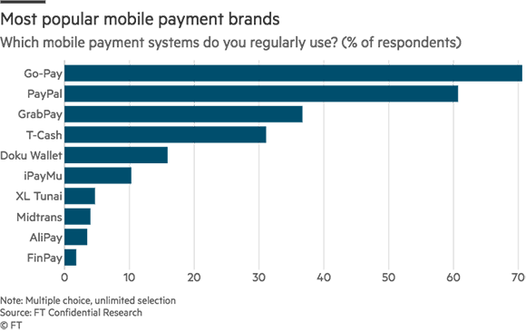

Unlike T-Cash, Go-Pay and GrabPay do not allow transactions beyond their own networks. This will change next year as they expand their e-wallet services to include transactions at points of sale. Meanwhile, PayPal is only available for purchasing goods online and mostly from foreign e-commerce sites.

T-Cash is still leading the tech race and is currently testing QR codes at 1,800 retailers, ahead of full deployment next year. Go-Pay and GrabPay, as well as major banks such as Bank BCA and BRI, are also expected to deploy QR code operations next year. This suggests players are converging on QR codes as the dominant technology, a move that will make the public adoption of mobile payments easier and allow for greater financial inclusion.

**Challenges remain**

While the regulatory environment has generally been supportive, it is not perfect. At least five e-wallet services have temporarily stopped accepting bank transfers to top-up e-wallet credits due to a lack of regulatory clarity.

E-wallet providers had been operating under the impression it was legal to conduct transactions as long as they were carried out within their own network. This changed last month when Bank Indonesia clarified that only e-money licence holders could operate e-wallet transactions. GrabPay and three e-wallets from Indonesia's top e-marketplaces - TokoCash from Tokopedia, BukaDompet from Bukalapak and ShopeePay from Shopee - have since been banned from accepting top-ups. These companies are seeking to obtain e-money licences and are expecting full compliance by the end of the year.

Also, Bank Indonesia has not addressed the unfair competition created by subsidies, which private companies can offer but banks, tightly regulated and publicly listed, cannot. Go-Pay and GrabPay offer discounts for items such as taxi rides and food delivery bought using their platforms, while T-Cash uses subsidized transactions to gain new users.

Meanwhile, all electronic payments through the coming National Payment Gateway will have to be processed by networks that are at least 80 per cent domestically owned. This will stifle foreign competition and therefore hinder technological advances, and make it harder for Indonesians to use mobile payments to purchase goods and services abroad.

*This article was first published on November 22 by*[*FT Confidential Research*](http://ft.com/ftcr)*.*

|  |
| --- |
| [FT Confidential Research](http://ft.com/ftcr) is an independent research service from the Financial Times, providing in-depth analysis of and statistical insight into China and Southeast Asia. A team of researchers in these key markets combine findings from proprietary surveys with on-the-ground research to provide predictive analysis for investors. |

When Uber launched in Indonesia in 2014, the vast majority of the country’s 260 million people couldn’t use it. Credit card ownership isn’t common here, and payment by credit card was the app’s only option.

Uber’s magic depends on it: You add your credit card number once and never worry about payment again. Everything happens in the background.

To serve more Indonesian customers, the ride-hailing firm had to sacrifice some of its dearly-held user experience and had to learn to [handle cash](https://www.techinasia.com/uber-begins-cash-payments-indonesia).

Indonesia, like many developing countries, lacks established cashless payment methods and that’s a major hurdle to digital economy growth.

AD. Remove this ad space by [subscribing](https://www.techinasia.com/subscription?ref=banner-ad-top).[Support independent journalism.](https://www.techinasia.com/subscription?ref=banner-ad-bottom)

It’s not just credit cards. Per [World Bank’s 2014 data](http://datatopics.worldbank.org/financialinclusion/country/indonesia" \t "_blank), the majority of the adult population didn’t even have bank accounts.

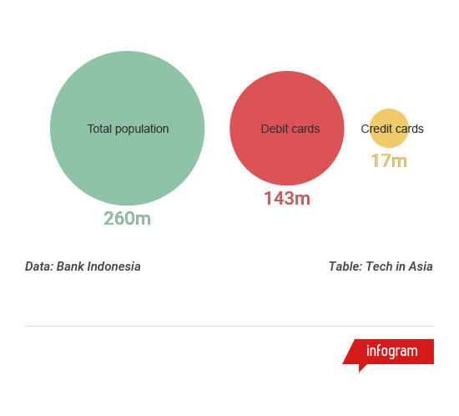

For the digital economy to reach its expected [US$130 billion target by 2020](http://www.reuters.com/article/indonesia-retail/indonesia-targets-130-bln-in-e-commerce-transactions-by-2020-idUSJ9N14Y02J" \t "_blank), it needs a breakthrough in cashless payments.

Now, government agencies, banks, telcos, and fintech startups are scrambling to lead the shift away from cash.

There are two main scenarios: one involves the formal banking sector casting a much wider net, dramatically increasing the number of bank accounts, debit, and credit cards in use. In the US, for example, credit cards are a ubiquitous form of cashless payment. According to Statista, there are over a [billion credit cards](https://www.statista.com/statistics/245385/number-of-credit-cards-by-credit-card-type-in-the-united-states/" \t "_blank) in circulation there. That’s for a population of around 320 million people.

Indonesia’s Central Bank (BI) counts roughly [17 million credit cards](http://www.bi.go.id/en/statistik/sistem-pembayaran/apmk/contents/jumlah%20apmk%20beredar.aspx" \t "_blank) in a country of around 260 million people.

AD. Remove this ad space by [subscribing](https://www.techinasia.com/subscription?ref=banner-ad-top).[Support independent journalism.](https://www.techinasia.com/subscription?ref=banner-ad-bottom)

It looks a bit better when it comes to debit cards – 143 million are in circulation according to BI. Most of these cards can’t be used for online shopping, and there are only about one million card readers (EDCs) across Indonesia, which means that debit card owners often can’t use them when they want to.

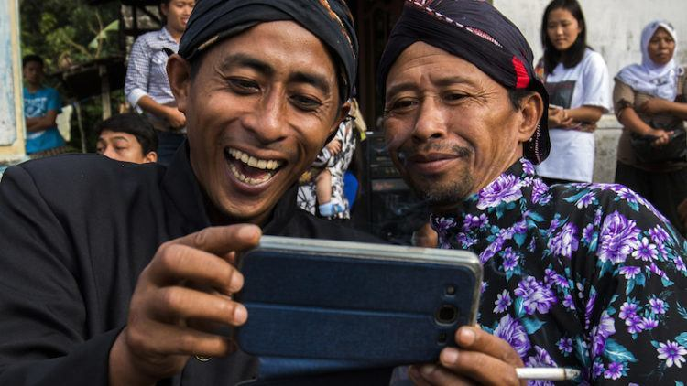

Photo credit: [Eko Susanto.](https://www.flickr.com/photos/130075348@N08/27178192056/" \t "_blank)

The other scenario looks toward China, where third-party payment providers like Alipay and Tencent Pay have seemingly [all but replaced cash overnight](https://www.nytimes.com/2017/07/16/business/china-cash-smartphone-payments.html" \t "_blank).

This was made possible because of the smartphone boom. Credit stored on mobile wallets can be transferred instantaneously and at low cost. In China, the ecosystem of mobile payments has branched out to the point that you use your WeChat app to pay whether you’re at the restaurant or a traditional market.

With regard to [mobile phone adoption](https://www.slideshare.net/wearesocialsg/digital-in-2017-southeast-asia" \t "_blank), Indonesia has done well: 91 percent of the population now own a mobile phone, 47 percent of those are smartphones.

With a payments-ready phone within everyone’s reach, Indonesia might leapfrog card-based payments altogether, some analysts believe. Macquarie Research, the intelligence arm of global financial consultancy Macquarie, suggests this as a possible outcome in its recent [Indonesia fintech report](https://www.macquarieresearch.com/rp/d/r/publication.do?f=C&pub_id=7318288&file_name=ASEANBanks130417xe270543.pdf" \t "_blank). KPMG, which has also created a substantial report on [payments in Indonesia](https://assets.kpmg.com/content/dam/kpmg/id/pdf/2017/01/id-retail-payments-in-indonesia.pdf" \t "_blank), comes to a similar conclusion.

The scenarios aren’t mutually exclusive – traditional bank payments and alternative forms of e-payments can co-exist. Both depend on the technical innovation and agility brought about by fintech startups.

But at this point, no one can say how the shift from cash will play out in Indonesia – and which businesses and institutions will reap the largest rewards.

## The state of pay

So how do people pay for things in Indonesia?

In traditional offline retail, there’s little choice but to pay in cash. Shops in malls, restaurant chains, or hotels have card terminals, but once you’re outside of established retail, that option no longer exists.

To settle bills like electricity, water, or internet, Indonesians use ATMs, online banking, or pay in cash through agents, for example at convenience stores.

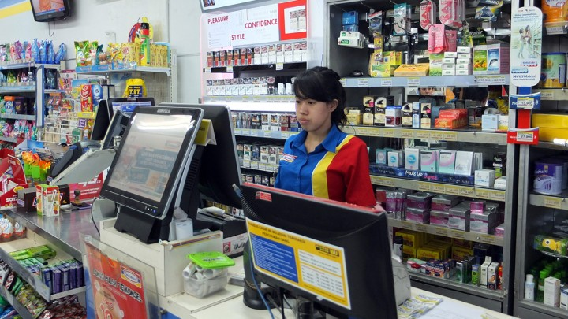

Convenience stores let customers pay bills and buy digital vouchers at the counter. Photo credit: Tech in Asia.

For payments in digital environments, there’s no obvious solution. Shoppers are smothered with choice.

Screens with an overwhelming amount of payment options – here from popular shopping site Tokopedia – are common during the checkout process.

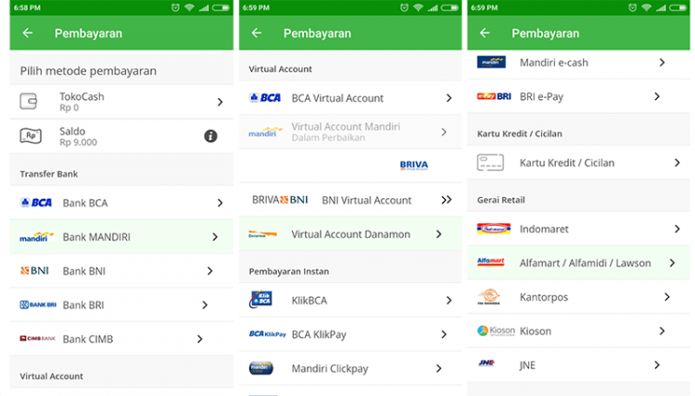

Screenshots from Tokopedia app.

The most common methods to settle online payments are ATM transfers and online banking, followed by cash-on-delivery (COD) – when you pay in cash through the delivery person.

The Indonesian[Association of Internet Providers](https://dailysocial.id/post/apjii-pengguna-e-money-baru-mencapai-07-dari-total-responden" \t "_blank) (APJII) and [Xendit](https://blog.xendit.co/2017/06/13/popular-payment-methods/" \t "_blank), a payment gateway, both come to this conclusions in their research.

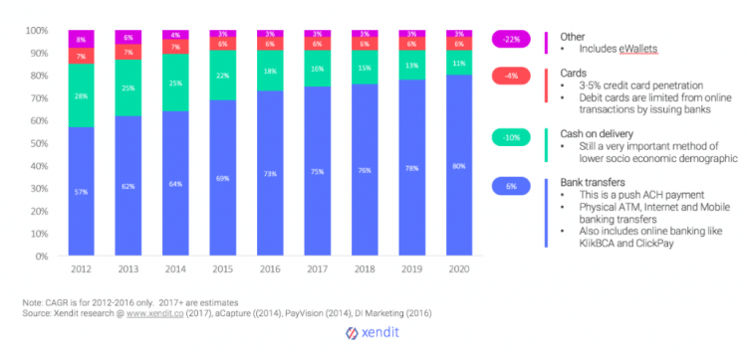

Chart: [Xendit](https://blog.xendit.co/2017/06/13/popular-payment-methods/" \t "_blank).

A slightly different view is presented by eCommerce IQ in its analysis of data from ecommerce enabler aCommerce.

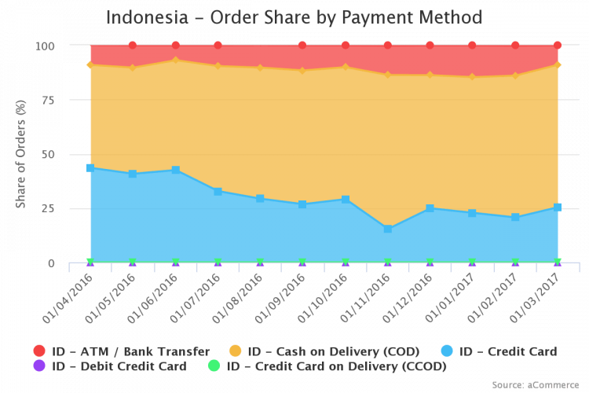

Chart: [EcommerceIQ](https://ecommerceiq.asia/payment-methods-southeast-asia/" \t "_blank).

It sees an overwhelming demand for COD, with ATM payments coming in second. That’s because the data was collected mainly from e-retailers that send out physical goods, aCommerce IQ told Tech in Asia. This skews results in favor of COD.

Xendit and APJII’s research includes people’s preferences when paying bills and digital goods like tickets and gaming vouchers.

Consumers may have arranged themselves with ATM transfers, online banking, and COD payments, but these methods have obvious disadvantages.

It’s risky for businesses to trust a delivery person with cash. It also adds to cost of transactions, delays in settlements, and more returns or undelivered items. ATM payments and online payments are a hassle for customers, and they’re also not instantaneous. Overall, this friction leads to many unsettled payments. Industry players speak of a [80 percent card abandonment rate](https://www.slideshare.net/iese_id/indonesias-first-alldigital-credit-card-for-ecommerce-akshay-garg" \t "_blank).

In 2017, card payments and other forms of cashless payments, such as through mobile wallets, only account for a small fraction of overall payments in Indonesia – even though they promise a smoother experience.

LINKS-

<https://www.statista.com/outlook/296/120/digital-payments/indonesia>

<https://www.linkedin.com/pulse/mobile-payment-war-indonesia-bagus-aditya>

### FinTech

**THE BOOMING ECONOMY IN INDONESIA HAS CARVED A CLEAR PATH TO LEVERAGE FINTECH STARTUPS AND FINTECH IN INDONESIA BECAME ONE OF THE MOST PROMISING INDUSTRIES.**

But what is FinTech? FinTech, or fintech, is an acronym for financial technology. It is the new technology and innovation that set forth to create a better financial landscape for both consumers and businesses. It is also said to compete with traditional financial methods in the form of delivery.

With **US$500 billion of infrastructure investment** planned for the next five years, the emergence of new markets of FinTech sector in Indonesia is set for a new path. With the high-middle class growth, Indonesia is now a country with high internet penetration.

More than that, Indonesia serves as a fertile land for FinTech growth especially markets for**lending, cards, and payments.** More than 150 FinTech startups are found in Indonesia, a **growth of 78 percent since 2015**.

Some of the promising FinTech startups in Indonesia include Jurnal, Cashlez, TunaiKita, Payfazz, and KoinWorks. In Indonesia alone, 44% of FinTech companies are payment service providers.

This article intends to provide a comprehensive view of FinTech landscape in Indonesia, its viability and challenges, as well as give insights to financial services, regulatory sectors, and most importantly FinTech startups [doing business in Indonesia](https://www.cekindo.com/services/business-set-up).

## AN OVERVIEW OF FINANCIAL TECHNOLOGY IN INDONESIA

FinTech refers to a company that makes use of technology to offer financial services, examples of FinTech companies in Indonesia might be Kartuku, HaloMoney, Doku, and Veritrans.

The rapid growth of FinTech space unfolds substantial opportunities and Indonesia is one of those countries adopting the emerging technology. In addition to that, the large **unbanked population** in Indonesia has spurred innovation. Adoption of mobile banking and FinTech changing the financial landscape in Indonesia.

### The Leading Players

Indonesia is home to many of the profitable and fastest growing banks in the world. The financial landscape in Indonesia can be segmented into different categories based on funding, lending and performance trends and drivers. The categories, according to KPMG, are as follows:

#### The Big Four Banks

The [finance sector](https://www.cekindo.com/sectors/banking) is lead by three state-owned banks—Bank Mandiri, Bank Rakyat Indonesia (BRI), and Bank Negara Indonesia (BNI); and one private bank—Bank Central Asia (BCA). Based on Indonesia Banking Statistics, this category takes up 41% of national lending.

#### Larger Commercial Banks

Six sizeable commercial banks with 16% retail and corporate lending in Indonesia are CIMB Niaga, Danamon, Permata, Maybank Indonesia, Bank Tabungan Negara (BTN), and Panin Bank.

#### Other Smaller Commercial Banks

33% of national lending presents at these smaller commercial banks: 9 branches of foreign-owned banks, 12 joint-venture banks, 27 regional development banks, 13 Shariah Banks, and 44 conventional banks.

#### Rural Banks (BPRs) and Micro Finance Institution (MFIs)

2% of national lending presents at the 1,630 rural banks and other microfinance institutions in Indonesia. BPRs has a limited scope of activities compared to commercial banks and thereby less attractive to customers.

#### Multi-finance Companies

More than 200 multi-finance companies in Indonesia offer a total of 8% of national lending. They are licensed to offer leasing, credit card financing, consumer financing, and other lending services. These companies include Adira Dinamika Finance, BFI Finance, Clipan Finance, and Astra Sedaya Finance.

#### New Challengers

It is at the blossoming stage for crowdfunding, peer-to-peer (P2P) lending and other alternative up-and-coming FinTech lenders. Most platforms are in testing phases and are set to reach a critical mass in the not too distant future. With significant investments from large foreign investors, e-wallets are now expanding with rapid increase of customers.

There is a great opportunity for FinTech startups in Indonesia given the uneven availability of finance and low levels of financial inclusion.

### The FinTech Data

FinTech has achieved initial mass adoption in most countries and has gained significant market traction for the under-served populations.

According to a 2017 survey done by [Hootsuite](https://hootsuite.com/" \t "_blank), out of the 4.153 billion total population in Asia-Pacific region, there are 1.909 billion of internet users, 1.541 billion of active social media users, 3.999 billion of mobile subscription, and 1.441 billion of active mobile social users. Since 2016 in Asia-Pacific, Internet users is growing at 15%, active social media users at 25%, unique mobile users at 4% and active mobile social users at 35%. **At least two or more FinTech services are used by each consumer**.

According to [EY FinTech Adoption Index](https://www.ey.com/Publication/vwLUAssets/ey-fintech-adoption-index-2017/%24FILE/ey-fintech-adoption-index-2017.pdf), there is an average of 33% FinTech adoption globally. An average of 84% of consumers is aware of FinTech—a whopping 22% growth compared to the 62% in 2015.

Indonesian FinTech Ecosystem includes savings and investments, money transfer and payments, point of sale (POS), lending and borrowing, accounting, comparison, financial planning, crowdfunding, and cryptocurrency.

**Money transfer** and payments take up the highest percentage—50%, in all FinTech Ecosystems with the most digitally active customers.

## VIABILITY OF FINTECH INDUSTRY IN INDONESIA

While China is the clear leader in this emerging market of FinTech in Asia, Indonesia is now following suit and poised for growth.  Strong growth recorded in investments into FinTech startups also signal the future potential of the sector.

Being an archipelago country with 17,504 islands, limited infrastructure and credit information, FinTech in Indonesia has the ability to solve the financial inclusion challenges in Indonesia.

### Why FinTech?

FinTech startups are introduced in the favour of helping the backing sector to conquer the limitations of topography, reaching out to more remote areas.

Moreover, being the major players in the Indonesian banking market, **bank institutions** did not bother much about a customer friendly approach. Confusion and complications became a routine when issuing bank loans or searching information. Thus, FinTech in Indonesia is a sector with a great potential.

As mentioned, FinTech sector especially lending will continue to grow.  Its expansion will support small and medium businesses in Indonesia, as the main reason for their low productivity is due to poor access to financing.

### Three Crucial Factors for FinTech Growth in Indonesia

#### Customer’s Behaviour

The positive shift of customer’s behaviour towards digital services is obvious. This is because they see this financial technology very convenient; you can assess anytime, anywhere with any devices—in comparison with bank services that require submission in person.

#### Lower Fees

To reach the under-served segments and provide everyone lower transaction fees, government enhance the access to financial services.

#### High Restrictions

Small and medium businesses are having a hard time making use of particular banking services due to the highly restricted bank loans.

### Cash to Cashless

A few years ago, 99.5% of transactions in Indonesia were in cash. However, now we have witnessed the increased popularity of **cashless transaction**, with the emergency of FinTech startups. As of December 31, 2016, there were **more than 17.4 million credit cards** issued in Indonesia. For that, Indonesia is expanding FinTech in key financial services including payments and lending.

We see a lot of exciting trends driven by payment gateway providers such as DOKU, Midtrans, and Xendit, with hundreds of other FinTech innovations on the rise.

The credit card as a preferred payment, for example, it is convenient because there is no need for consumers to search for an ATM or to have some cash on hand. A credit card is also a great way for record-keeping with regular transaction statements for expenses and spending tracking.

With the increasing use of **e-money products**, the volume of bank transfer and online transactions is growing in Indonesia, even though the preferred payment method is still cash. The growth has shown no signs of slowing with FinTech startups around the world, including Indonesia pushing for a cashless society.

### Financial Inclusion

Indonesia is one of the **highest unbanked populations in the world**. Among the 58 million of small and medium enterprises in Indonesia, only 12% have access to credit because of the deficiency of credit history, statements or collateral. And even more shockingly, these small and medium businesses contribute 60.3% of the total GDP in Indonesia.

The Indonesian government is, therefore, pushing for financial inclusion. This is done in order to open up opportunities for institutions with traditional finance model, and FinTech new entrants.

### FinTech Awareness

The **Financial Services Authority (OJK) of Indonesia** and relevant agencies have been**holding FinTech festivals**to increase consumers’ awareness and access to new applications.

During the yearly FinTech conference Finspire 2017 on October 19, Mandiri Capital Indonesia (MCI) has invested approximately 300 billion IDR (US$22.4 million) in **seven FinTech startups**. Private lender BTPN also catches up with the digital wave and spent 1.3 trillion (S$131 million) to develop a digital platform.

For the purpose of sharing knowledge, insights and ideas on this financial service ecosystem, all FinTech organizations and regulators, financial institutions, digital professionals have gathered at this event. Investors, founders, students, entrepreneurs, and startups were invited to participate in this event to accelerate FinTech development and discuss the future of FinTech in Indonesia.

Furthermore, OJK with the support of Central Bank of Indonesia has implemented a FinTech registration system for startups. This has proved that FinTech is formally recognized. As of June 2017, a total of eight startups have registered, and much more in the process. The inauguration for FinTech Advisory Forum also happened around the same time to direct the FinTech industry’s development.

## THE CHALLENGES FOR FINTECH STARTUPS

There are also challenges in pursuing FinTech for all startups doing business in Indonesia.

### Image of Indonesian Banks

The very positive image of Indonesian banks gets in the way of entrepreneurial FinTech startups.

### Acceptance of Cashless Payment

In Indonesia, FinTech payment options for both in-person and online transactions are still not widely available at merchants. If they do offer option, consumers will have to pay an extra percentage for transaction.

### Proper Business License in Indonesia

Most large startups in Indonesia are riding the wave and came up with more applications for a cashless Indonesian society. However, to be totally cashless will still take some time, and lots of homework to do for all stakeholders. Because some companies still operate e-wallets without the right [business license](https://www.cekindo.com/services/business-import-licenses) in Indonesia.

### Overseas Competitor

The FinTech lending startups will face some competition on all fronts due to the foreign companies in Indonesia such as Chinese FinTechs.

### Regulation and Process Clarity

A big part of FinTech startups thinks that the [process of regulations](https://www.cekindo.com/bank-indonesia-regulation-fintech.html) in Indonesia is too slow and too ambiguous.  The government still needs to take steps to ensure clearer regulatory requirements and a better environment for FinTech startups—to boost the confidence of FinTech startup founders and investors in Indonesia.

Overall, starting a FinTech startup in Indonesia requires patience, mainly because of issuing licenses provided by OJK and Bank of Indonesia. However, the process itself might be ambiguous as there were new regulations.

Thanks to our vast network and regular consultations with the governmental institutions like OJK and Bank Indonesia, [Cekindo](https://www.cekindo.com/" \t "_blank) takes pride in assisting you with professional expertise while starting your FinTech business in Indonesia.

## FUTURE FOR FINTECH STARTUPS

2016 marked the first time that FinTech investments number overtook Southeast Asia’s ecommerce—the highest by amount with US$421M. Investments in Indonesian FinTech startups have hit a record in 2017 and expected to progress in 2018.

**Digital payments** hit a total transaction of US$18 million in 2017. Moving forward, the government in Indonesia also specifies FinTech integration and improved payment infrastructure the key for e-commerce.

In addition, OJK in Indonesia has been actively setting measures to promote the growth of FinTech starting a business in Indonesia, while giving out the appropriate guideline to manage potential risks and challenges.

**Read more:**[**Bank Indonesia launches regulation on FinTech**](https://www.cekindo.com/bank-indonesia-regulation-fintech.html)

Despite all great opportunities ahead, regulators in Indonesia will need to know how to **balance the desire to encourage new businesses, so as to intensify**competition, and provide better customer services in the sector, while protecting the system and consumers from excessively risky behaviour and potential disruption.

## PARTING NOTES

Being able to observe the current trends pushed by FinTech startups locally and globally, the future of FinTech landscape has a huge and optimistic potential in Indonesia.

If the government is able to provide rules with clarity and increase the data security and consumer protection, FinTech in Indonesia will become the national priority to improve the lives of all Indonesians. To fulfill this scenario, the government needs to resolve geographical barriers, tackle environmental challenges, and meet customer expectations.

### LINKS-

### <http://fintechnews.sg/20712/indonesia/fintech-indonesia-report-2018/>

### <https://www.forbes.com/sites/danielnewman/2018/07/03/exploring-5-trends-driving-the-fintech-revolution/#7a5d266f12c7>

### <https://www.techinasia.com/indonesian-fintech-in-2018>